Smart Attendance Management System - Project Proposal
Group: Abdullah BSSE-B

MILESTONE | VERSION | DATE(DD-MM-YYYY) | REMARKS
ERD Diagram | 1.0 | 26-04-2026
Schema | 1.0 | 26-04-2026

Milestone: Version 1.0: ERD Diagram
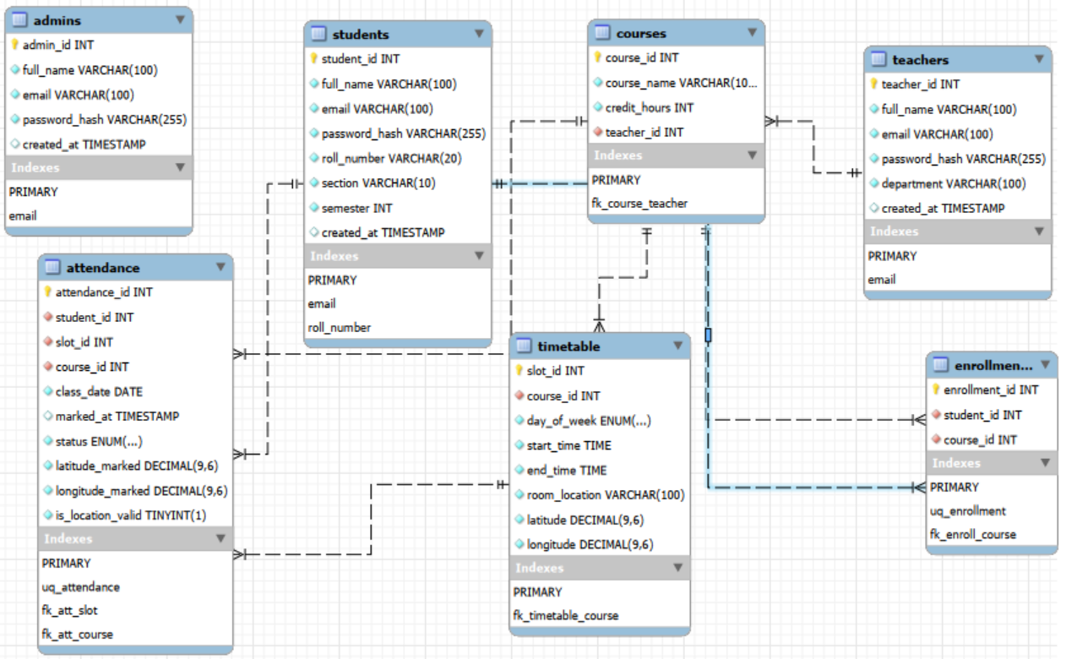

Milestone: Version 1.0: Schema
📋 Tables Overview

| # | Table | Purpose |
|---|-------|---------|
| 1 | `admins` | System administrators |
| 2 | `teachers` | Teacher accounts + login |
| 3 | `students` | Student accounts + login |
| 4 | `courses` | Courses linked to teachers |
| 5 | `enrollments` | Which student is in which course |
| 6 | `timetable` | Weekly class slots with GPS location |
| 7 | `attendance` | Attendance record per student per class per date |

1. `admins`

| Column | Type | Constraints | Description |
|--------|------|-------------|-------------|
| `admin_id` | INT | PK, AUTO_INCREMENT | Unique admin ID |
| `full_name` | VARCHAR(100) | NOT NULL | Admin's name |
| `email` | VARCHAR(100) | UNIQUE, NOT NULL | Login email |
| `password_hash` | VARCHAR(255) | NOT NULL | Bcrypt hashed password |
| `created_at` | TIMESTAMP | DEFAULT NOW() | Account creation time |

2. `teachers`

| Column | Type | Constraints | Description |
|--------|------|-------------|-------------|
| `teacher_id` | INT | PK, AUTO_INCREMENT | Unique teacher ID |
| `full_name` | VARCHAR(100) | NOT NULL | Teacher's name |
| `email` | VARCHAR(100) | UNIQUE, NOT NULL | Login email |
| `password_hash` | VARCHAR(255) | NOT NULL | Bcrypt hashed password |
| `department` | VARCHAR(100) | NOT NULL | Teacher's department |
| `created_at` | TIMESTAMP | DEFAULT NOW() | Account creation time |

3. `students`

| Column | Type | Constraints | Description |
|--------|------|-------------|-------------|
| `student_id` | INT | PK, AUTO_INCREMENT | Unique student ID |
| `full_name` | VARCHAR(100) | NOT NULL | Student's name |
| `email` | VARCHAR(100) | UNIQUE, NOT NULL | Login email |
| `password_hash` | VARCHAR(255) | NOT NULL | Bcrypt hashed password |
| `roll_number` | VARCHAR(20) | UNIQUE, NOT NULL | University roll number |
| `section` | VARCHAR(10) | NOT NULL | Class section e.g. BSSE-B |
| `semester` | INT | NOT NULL | Current semester |
| `created_at` | TIMESTAMP | DEFAULT NOW() | Account creation time |

4. `courses`

| Column | Type | Constraints | Description |
|--------|------|-------------|-------------|
| `course_id` | INT | PK, AUTO_INCREMENT | Unique course ID |
| `course_name` | VARCHAR(100) | NOT NULL | Course name |
| `credit_hours` | INT | NOT NULL | Credit hours |
| `teacher_id` | INT | FK → teachers | Assigned teacher |

**Relationship:** One teacher → Many courses

5. `enrollments`

| Column | Type | Constraints | Description |
|--------|------|-------------|-------------|
| `enrollment_id` | INT | PK, AUTO_INCREMENT | Unique record ID |
| `student_id` | INT | FK → students | The student |
| `course_id` | INT | FK → courses | The course |
| *(student_id, course_id)* | — | UNIQUE | No duplicate enrollments |

**Relationship:** Resolves Many-to-Many between students and courses

6. `timetable`

| Column | Type | Constraints | Description |
|--------|------|-------------|-------------|
| `slot_id` | INT | PK, AUTO_INCREMENT | Unique slot ID |
| `course_id` | INT | FK → courses | Which course |
| `day_of_week` | ENUM | NOT NULL | Mon/Tue/Wed/Thu/Fri |
| `start_time` | TIME | NOT NULL | Class start time |
| `end_time` | TIME | NOT NULL | Class end time |
| `room_location` | VARCHAR(100) | NOT NULL | Room name/number |
| `latitude` | DECIMAL(9,6) | NOT NULL | Classroom GPS latitude |
| `longitude` | DECIMAL(9,6) | NOT NULL | Classroom GPS longitude |

**Relationship:** One course → Many timetable slots

7. `attendance`

| Column | Type | Constraints | Description |
|--------|------|-------------|-------------|
| `attendance_id` | INT | PK, AUTO_INCREMENT | Unique record ID |
| `student_id` | INT | FK → students | Who marked attendance |
| `slot_id` | INT | FK → timetable | Which class slot |
| `course_id` | INT | FK → courses | Which course |
| `class_date` | DATE | NOT NULL | Actual date (e.g. 2025-04-26) |
| `marked_at` | TIMESTAMP | DEFAULT NOW() | Exact time of marking |
| `status` | ENUM | NOT NULL | Present / Absent / Late |
| `latitude_marked` | DECIMAL(9,6) | NOT NULL | Student's GPS latitude |
| `longitude_marked` | DECIMAL(9,6) | NOT NULL | Student's GPS longitude |
| `is_location_valid` | BOOLEAN | NOT NULL | Within allowed radius? |
| *(student_id, slot_id, class_date)* | — | UNIQUE | One record per student per class per day |

**Relationship:** Links students + timetable (Many-to-Many resolved)

Relationship | Type |
|---|---|
| Teacher → Courses | One-to-Many |
| Student ↔ Courses | Many-to-Many (via enrollments) |
| Course → Timetable slots | One-to-Many |
| Student ↔ Timetable | Many-to-Many (via attendance) |

🔑 Key Constraints Summary

| Table | Primary Key | Foreign Keys | Unique Constraints |
|---|---|---|---|
| admins | admin_id | — | email |
| teachers | teacher_id | — | email |
| students | student_id | — | email, roll_number |
| courses | course_id | teacher_id | — |
| enrollments | enrollment_id | student_id, course_id | (student_id, course_id) |
| timetable | slot_id | course_id | — |
| attendance | attendance_id | student_id, slot_id, course_id | (student_id, slot_id, class_date) |

